Name
10th Magnitude [Company address]
Operations Discovery
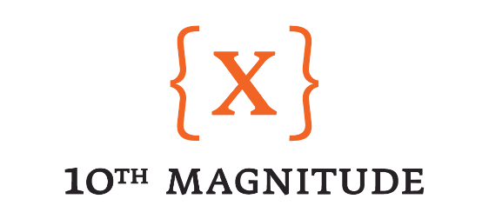

Operations Discovery - Overview

Description

The goal of Operational discovery is to understand how to support your Azure deployment and workloads day in and day out. Understanding how your organization currently supports servers and applications can help provide a lens into your requirements and what needs to be built in Azure.

Approach

During this design session we will be diving into your current support and monitoring practices. We will also focus on how information regarding support and design decisions that affect support teams is shared.

Goal

The goal of this session is to obtain a clear understanding of your monitoring and support functions. This information will be used to create the design for the deployment heading into the next phase of the project.

Operations Discovery – Questions

The following questions will guide us in understanding the structure of the Azure deployment that makes sense for the organization. Feel free to answer these questions ahead of the Cloud Design Sessions if possible. As part of the design sessions, we will ensure that these questions are answered in order to progress to the design and build phases of the project.

- Who is responsible for the monitoring, event management and analysis of servers and services?
  - Performance analyst team is responsible for performance analysis of servers and services
    - Server operations team uses data to pro-actively engage servers and services and performance planning
  - Cybersecurity for event management of syslog services
- Are there application SLAs and if so, who is responsible for maintaining them?
  - To be defined
- What applications, servers, services etc. are currently being monitored?
  - All servers
  - All production applications
  - Services as defined by application owners
- What application/system monitoring tools are currently in use?
  - Solarwinds
  - SQL - Spotlight
  - Netscout - new
- How is the monitored data being utilized? IE trend analysis and reporting, preventative maintenance, alerting etc.
  - Trend analysis
  - Preventative maintentance
  - Alerting
- Is there a NOC type dashboard in use by IT operations?
  - Solarwinds
  - SQL - Spotlight
  - Netscout - new
- How is patching and maintenance on applications, servers and services handled and who is responsible for managing maintenance?
  - Server operations team manages with application owners involvment
  - Ivanti Security Controls for O/S patching
  - ManageEngine Patch Connect Plus - 3rd party application patching
- Who is responsible for securing applications and infrastructure?
  - Cybersecurity provides policies and guidelines
  - Server Operations implements
- What kind of data loss protection systems are in place?
  - No comprehensive DLP product in place currently
  - Sophos encryption on HR file share (HIPPA)
- How is application and infrastructure security maintained, IE network security, identity, server hardening etc.
  - Cybersecurity provides policies and guidelines
  - Server Operations implements
- Is there a formal change management process and if so, what does that look like?
  - Change management is manged in ServiceNow
- How is operations staffed? IE 24/7 365 or 8x5 with on-call rotations
  - Standard H&P hours are 8am-5pm Central with on-call roations
- How is BCDR managed? backups, DR etc.
  - CommVault backups with offsite replicaiton
  - Avamar backups with offsite replication
  - BCDR project currently active

